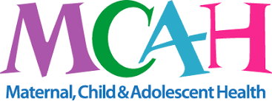 | CHILD HEALTH DOMAIN
NUTRITION/PHYSICAL ACTIVITY | CHILD INJURY PREVENTION | ORAL HEALTH | CHILDREN/YOUTH WITH SPECIAL HEALTH CARE NEEDS | GENERAL INFORMAITON
Nutrition/Physical Activities | The Maternal, Child and Adolescent Health (MCAH) Division’s Nutrition and Physical Activity (NUPA) initiative works to make good nutrition and regular physical activity the preferred and easy lifestyle choice for California women of reproductive age and their families.  Guidelines & Resources:  https://www.cdph.ca.gov/Programs/CFH/DMCAH/NUPA/Pages/Guidelines-and-Resources.aspx  Women and Infant Children:  https://www.cdph.ca.gov/Programs/CFH/DWICSN/Pages/Program-Landing1.aspx  Me and My Family  https://www.cdph.ca.gov/Programs/CFH/DMCAH/NUPA/Pages/General.aspx  Comprehensive Perinatal Services Information:  https://www.cdph.ca.gov/Programs/CFH/DMCAH/CPSP/Pages/default.aspx  Gestational Diabetes and Postpartum Care  https://www.cdph.ca.gov/Programs/CFH/DMCAH/Pages/Diabetes/Gestational-Diabetes-and-Postpartum-Care.aspx  First Five of San Benito County  https://www.first5sanbenito.org/
Child Injury Prevention | Vaccinations: Vaccines are very important to your baby’s health. When you get vaccinated against whooping cough and the flu during your pregnancy, you will pass some immunity (protection) to your baby. However, that protection will begin to decrease over time, leaving your infant vulnerable to disease. Make sure he or she gets vaccinated according to CDC’s childhood immunization schedule for safe, proven disease protection.  Vaccination After Pregnancy: It is safe for a woman to receive vaccines right after giving birth, even while she is breastfeeding. Vaccination after pregnancy is especially important if you did not receive certain vaccines before or during your pregnancy. For more information, please call Public Health Services of San Benito County (831)637-5367.  Safe Kids of San Benito County - Safe Kids Worldwide is a global network of organizations whose mission is to prevent accidental childhood injury, a leading killer of kids. Safe Kids Coalition of San Benito County is one of 400 coalitions across the United States with partners in more than 30 countries. Safe Kids meets once a month for an hour and covers topics on injury and prevention on but not excluded to fire, pedestrian, oral health , car seats, home, medications, falls, recalls on child products, swim, sports, and play. If you are interested, please call Public Health Services, Safe Kids Coordinator, Ofelia Toledo Prieto (831)637-5367. Or follow Safe Kids Coalition of San Benito County on social media.
Oral Health | Physiologic changes during pregnancy may result in noticeable changes in the oral cavity. These changes include pregnancy gingivitis, benign oral gingival lesions, tooth mobility, tooth erosion, dental caries, and periodontitis. It is important to reassure women about these various changes to the gums and teeth during pregnancy and to reinforce good oral health habits to keep the gums and teeth healthy.
Pregnant women may also be at risk for cavities due to changes in behaviors, such as eating habits. Women who have a lot of cavity-causing bacteria during pregnancy and after delivery could transmit these bacteria from their mouth to the mouth of their baby. Early contact with these bacteria and to other sugars, such as from frequent snacking or taking a bottle to bed, can lead to early childhood cavities and the need for extensive dental care at a young age. A great resource is for oral health during and after pregnancy is
https://www.mchoralhealth.org/PDFs/OralHealthPregnancyConsensus.pdf
https://www.mchoralhealth.org/

Please view these videos for more information:
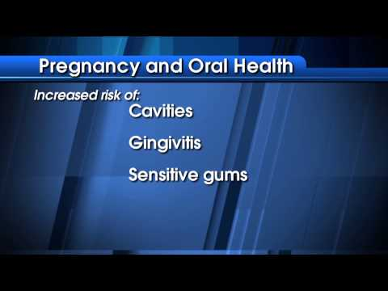

Healthy Tips for Tiny Teeth
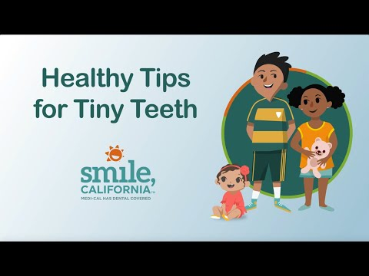

Medical Covers During Pregnancy
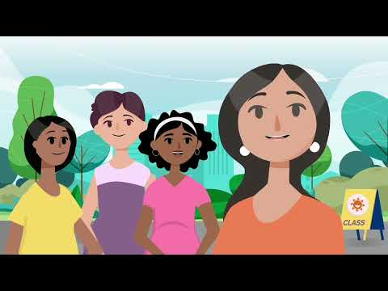

For more information concerning oral health visits, oral health tips for your baby or a free oral health assessment, please call the San Benito County Oral Health Program at (831)637-5367
CHILDREN/YOUTH WITH SPECIAL HEALTH CARE NEEDS | In California, nearly one in seven children are estimated to have special health care needs. Children and youth with special health care needs (CYSHCN) include infants, children, and youth from birth to age 21 who have one or more chronic physical, developmental, behavioral, or emotional conditions, and require special health and support services.  CCS  The CCS program provides diagnostic and treatment services, medical case management, and physical and occupational therapy services to children under age 21 with CCS-eligible medical conditions. Examples of CCS-eligible conditions include, but are not limited to, chronic medical conditions such as cystic fibrosis, hemophilia, cerebral palsy, heart disease, cancer, traumatic injuries, and infectious diseases producing major sequelae. CCS also provides medical therapy services that are delivered at public schools.  Local CCS Resources for San Benito County  Please call: Public Health Services ask for CCS personal (831)637-5367 or please go to HHSA.cosb.us website and search public health / CCS  Profile of a child with special health care needs  https://www.cdph.ca.gov/Programs/CFH/DMCAH/CDPH%20Document%20Library/Communications/Profile-CYSHCN.pdf  Special Parents Information Network Resource  Families confront enormous challenges in raising a child with special needs. They must navigate through multiple and highly complex service systems and process huge amounts of often conflicting information about their child's disability. Difficulties in coping with the strain on the family's physical, emotional, and economic resources make it difficult to maintain a functional and cohesive family. Confidence and mastery of the unique skills required to effectively parent a child with special needs are necessary goals that are often not fully met. One of the most efficient and effective ways for parents to meet these challenges is to network with other parents who have experience in raising a child with special needs. Please see the following link:  https://www.spinsc.org/
General Information | Opioids and Pregnancy  https://www.cdph.ca.gov/Programs/CFH/DMCAH/CDPH%20Document%20Library/Communications/Opioids_Pregnancy_Questions_Poster_LetterSize.pdf  Los Opioides y El Embarazo  https://www.cdph.ca.gov/Programs/CFH/DMCAH/CDPH%20Document%20Library/Communications/Opioids_Pregnancy_Questions_Poster_LetterSize_sp.pdf  Perinatal Mood Disorder  https://www.cdph.ca.gov/Programs/CFH/DMCAH/Pages/Communications/Maternal-Mental-Health.aspx  Perinatal Mood Disorder Video (Spanish)  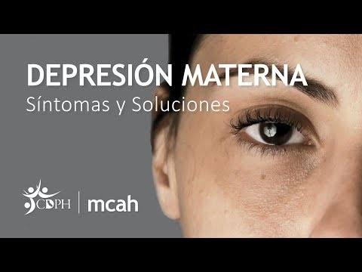  Perinatal Mood Disorder English Video  