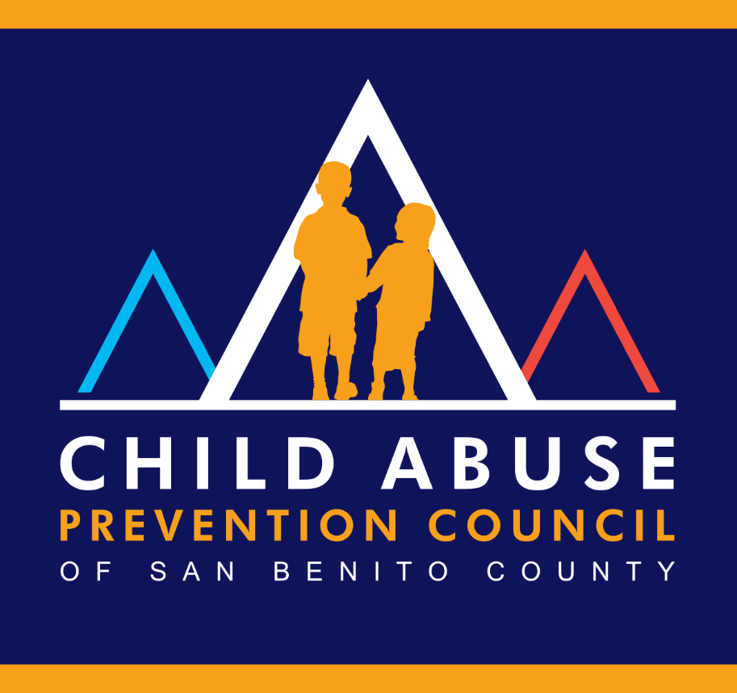

AGENDA PACKET

December 1, 2022, at 1:30 PM

IN PERSON at the EPICENTER

440 San Benito St, Hollister, CA 95023

Documents related to agenda items that are distributed to the San Benito County CAPC less than 72 hours prior to the meeting shall be available for public inspection at 1111 San Felipe Road, Suite 205, Hollister, CA 95023. Documents distributed to the CAPC at the meeting will be available at the meeting or after the meeting.

Child Abuse Prevention Council of San Benito County

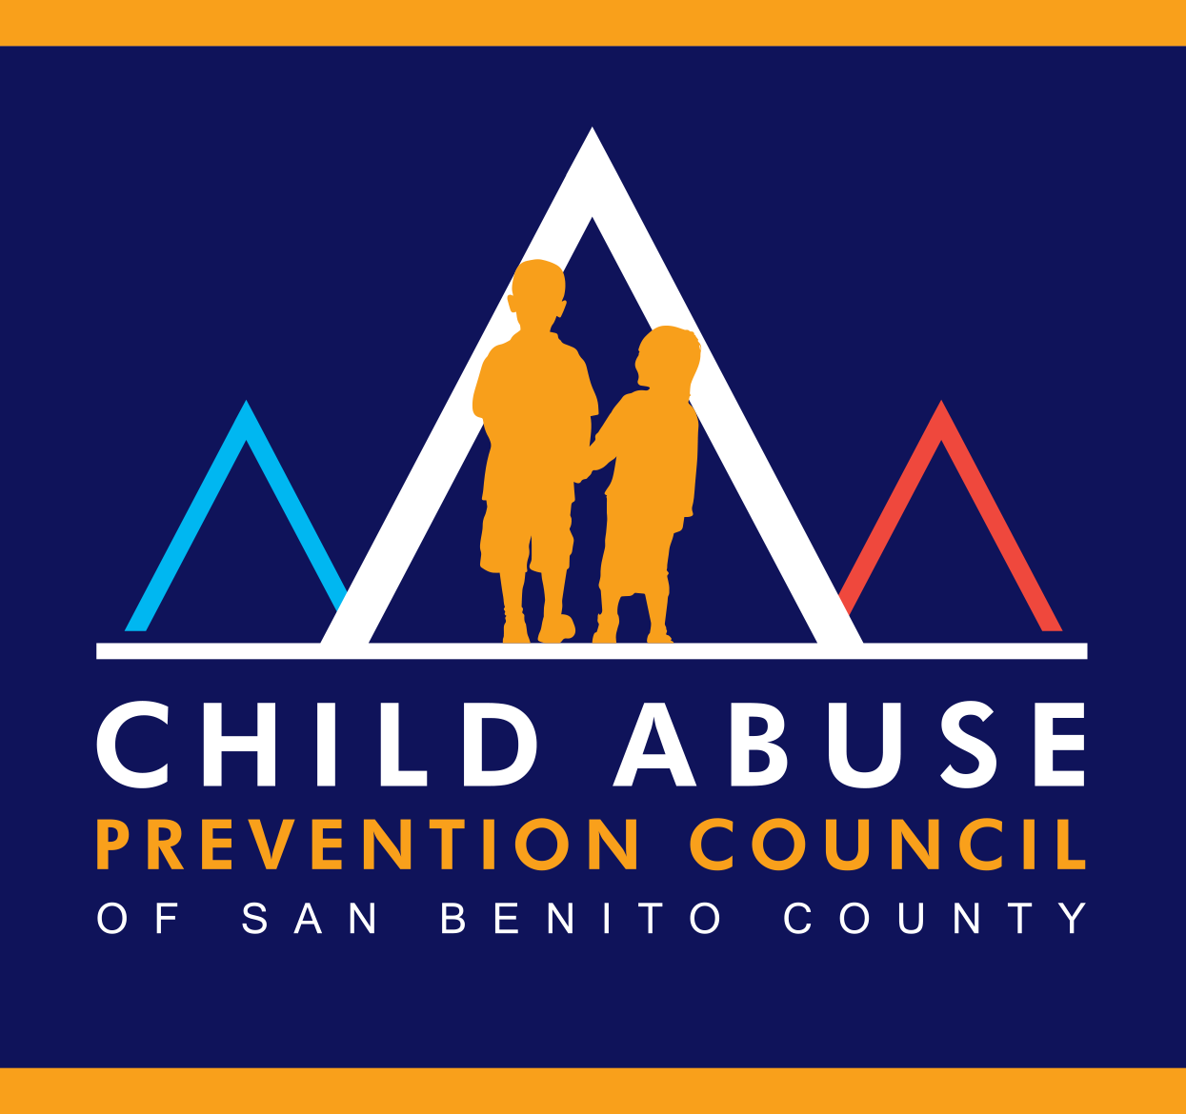

Erica Elliot, Chair
Eric Taylor, 2nd Chair
Esther Curtice, Secretary

Kendra Bobsin
Thomas Breen
Krystal Lomanto
Ashlyn Canez
Joshua Mercier

December 1, 2022
1:30 p.m. to 2:30 PM

In Person at the EPICENTER
440 San Benito St, Hollister, CA 95023

- Call to Order & Roll Call

- Acknowledge Posting of Agenda

- Public Comment – This item is reserved for persons wishing to address the CAPC on any matter not on the regular agenda. Persons wishing to address a particular agenda item should speak during that agenda item. Public comment is limited to five minutes per guest unless the Council determines that more time is needed.

- No minutes to approve

- Old Business: (discussion only)

- New Business: (discussion only)

- Discuss membership of CAPC and next steps as a group
  - Recruit new members/representatives from:
    - Public child welfare services: including the county welfare or children’s services department, the probation department, and licensing agencies;
    - The criminal justice system: including law enforcement, the office of the district attorney, the courts, and the coroner;
    - Prevention and treatment services: including medical and mental health, community-based social services, and public and private schools; and
    - Community representatives: including volunteers, civic organizations, and the faith-based community.
- CAPC Coordinator position
  - Review the Coordinator RFP from previous years

- Action Items: (motion required)

8. Member Announcements:
9. Adjournment: (motion required)

