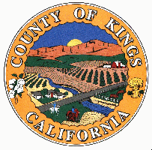<EMPTY>.

* At least 18 years of age.
* In good physical and mental health.
* An understanding of the safety, permanence, and well-being needs of children and non-minor dependents who have been victims of child abuse and neglect, and a capacity and willingness to meet those needs, including the need for protection, and a willingness to make use of support resources offered by the agency, or a support structure in place, or both.
* An understanding of children’s or non-minor dependents’ needs and development, effective parenting skills or knowledge about parenting, and a capacity to act as a reasonable and prudent parent in day-to-day decision making.
* An understanding of his or her role as a Resource Family and a capacity to work cooperatively with the County and other service providers in implementing a child’s or non-minor dependent’s case plan.
* The financial ability within the household to ensure the stability and financial security of the family.
* An ability and willingness to maintain the least restrictive and most family-like environment that serves the needs of a child or non-minor dependent.
* Demonstrate an understanding of the rights of children or non-minor dependents in care and his or her responsibility to safeguard those rights.
* Knowledge and willingness to prepare a child for adulthood or to prepare a non-minor dependent for the transition to independent living.

.

*To Request an RFA Application contact:*

*Sylvia Zendejas-Social Worker*

*Melissa Perez-Social Worker*

*Julissa Orozco- Social Worker*

*Charlene Lord-Social Work Supervisor*

*San Benito County Human Services Agency*

Phone: (831)636-4382

Fax: (831) 637-5510

1111 San Felipe Rd., Suite 205

Hollister, CA 95023

Or email:

[rfa@cosb.us](mailto:rfa@cosb.us)

# Caregiver Qualifications

***It’s not a job; it is a commitment to our community’s children.***

san benito County Resource Family Approval (RFA) Program



* Orientation
* 12 hour RFA

Pre-Approval Training

* CPR/First Aid Certified
* Additional training as

needed

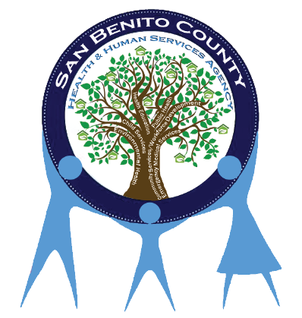

#### What is the Resource Family Approval Process?

* One application.
* One background check
* Combined Home environment and permanency assessments.
* Pre-approval and post-approval training for all families.

#### Pre-approval training

**Post-approval training**

#### What is a Resource Family Approval?

* An individual, couple, or family who wants to provide care to a related or unrelated child who is under the jurisdiction of the juvenile court, or otherwise in the care of a county child welfare agency or probation department.
* A Resource Family has successfully met approval standards which include home and ground inspection, risk assessment, background clearances, training and a permanency assessment as established in the Resource Family Written Directives.
* Upon approval, a Resource Family is considered to be approved for providing foster care, becoming a legal guardian or adopting a child without going through additional processes.

#### What is a Resource Family?

RFA is a unified, family friendly and child-centered resource family approval process that replaces the existing multiple processes, eliminates duplication, and increases approval standards by incorporating a comprehensive family evaluation of all families that want to foster, adopt, or provide legal guardianship to a child.